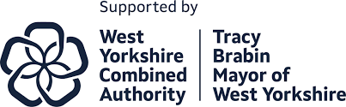

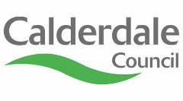
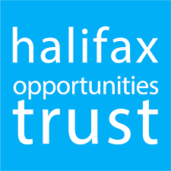
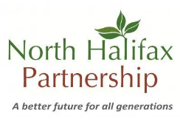

Culture Community Fund

Welcome to the Culture Community Fund!

This fund is supported by the UKSPF programme in Calderdale and available for activities and events being held in:

Ovenden

Illingworth

Mixenden

Warley

Boothtown

Park

For more details on what the fund can support please see the Culture Fund Criteria. Below is a short application form to capture the details and thinking behind your idea or project.

Don’t feel you have to apply alone – you can always give us a call on 01422 392767 and we can help you through the application process.

Application Form

Section 1 – Who is applying?
Name of organisation or group
What does the group or organisation do?
Who is the main contact? | Name:  Address:  Email:  Telephone:
Is it a voluntary, community or faith group? | Yes 0 No 0
Does it have a constitution or other governing document? *  *Please note this does not exclude you from applying but we may be able to offer further support for your group such as fast tracking you to become constituted, linking you to another group for support or NHP managing payments for your application | Yes 0 No 0
Does it have its own bank account? | Yes 0 No 0
Would you be able to evidence key policies are in place for your group? (i.e. safeguarding, health and safety, Environmental Health and public liability insurance?) | Yes 0 No 0
Is it open to everyone? If no, please explain, e.g. only people with disabilities, or certain age groups | Yes 0 No 0  If no, please explain:

Section 2 – Your idea
Project Title
Give your project a short title so it can be easily identified
Project Summary
Please describe your project and what you want the grant to fund (add a separate sheet if required)

How will the funded project meet the aims and objectives of the Culture Community Fund ?
- Provide cultural, heritage and/or sport opportunities for local people

- Build on the success of Culturedale Year of Culture 2024.

- Reflect the remarkable stories, talents, and traditions of Calderdale

- Strengthen local communities
Approximately how many people will benefit from the project?
Who will the project benefit?
You might like to tell us about the ways your project is inclusive and accessible.
Where is the project located?
When will the project begin and for how long will it last?

How is this project sustainable? What is your forward plan? (i.e. accessing alternative funding, self-funding etc)

Section 3 – How much are you applying for?
Please breakdown your expected costs below:
Item | Cost £
Total Amount Applied for:

How will you monitor success of your project? Eg. Collecting data on participants, age, gender, postcode

Signed: _______________________________

Position in the organisation /group: _______________________________

Completed application forms can be emailed to the Staying Well Team: stayingwellproject@nhpltd.org.uk
or you can call us on 01422 392767.
If you’ve got a good idea for a project, you are welcome to contact us.
We are more than happy to support you through the design and application process.

Culture Community Funding is a service funded by UKSPF, and is managed by North Halifax Partnership and Halifax Opportunities Trust.
North Halifax Partnership Ltd is registered as a ‘data controller’ with the Information Commissioner’s Office under the Data Protection Act. You can find out more about the Data Protection Act, and your legal rights at https://ico.org.uk
North Halifax Partnership Ltd will only use your personal information for the purpose which we have stated when we collect that information, and we will not collect unnecessary information about you, or keep your information for longer than it is needed. We will ensure your personal data is held securely and is not seen by anyone who should not see it. Please go to https://northhalifaxpartnership.org/privacy-notice/ to read our Privacy Notice on our website.

